Doug Strouth

CIS228

Code for Chapter 3 City Jail

CREATE TABLE Aliases

(Alias_ID NUMBER(6),

Criminal_ID NUMBER(6,0),

Alias VARCHAR2(10)); 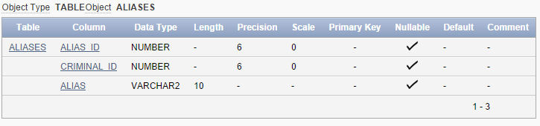

CREATE TABLE Criminals

(Criminal_ID NUMBER(6,0),

Last VARCHAR2(15),

First VARCHAR2(10),

Street VARCHAR2(30),

City VARCHAR2(20),

State CHAR(2),

Zip CHAR(5),

Phone CHAR(10),

V_status CHAR(1) DEFAULT 'N',

P_status CHAR(1) DEFAULT 'N');

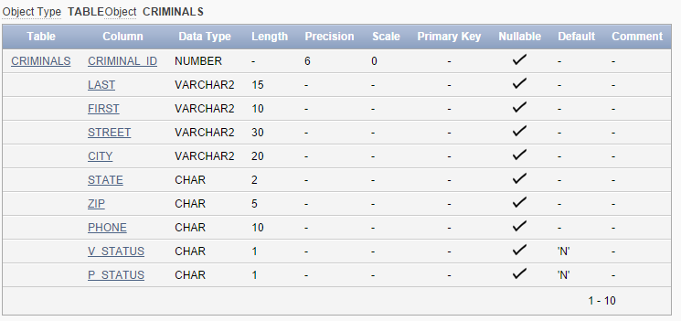

CREATE TABLE Crimes

(Crime_ID NUMBER(9,0),

Criminal_ID NUMBER(6,0),

Classification CHAR(1),

Date_charged DATE,

Status CHAR(2),

Hearing_date DATE,

Appeal_cut_date DATE);

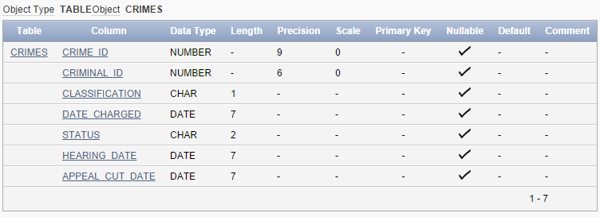

CREATE TABLE Sentences

(Sentence_ID NUMBER(6),

Criminal_ID NUMBER(6),

Type CHAR(1),

Prob_ID NUMBER(5),

Start_date DATE,

End_date DATE,

Violations NUMBER(5));

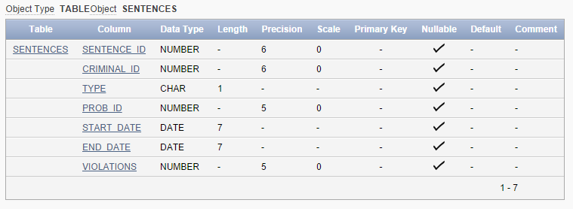

CREATE TABLE Prob_officers

(Prob_ID NUMBER(5),

Last VARCHAR2(15),

First VARCHAR2(10),

Street VARCHAR2(30),

City VARCHAR2(20),

State CHAR(2),

Zip CHAR(5),

Phone CHAR(10),

Email VARCHAR2(30),

Status CHAR(1) DEFAULT 'A');

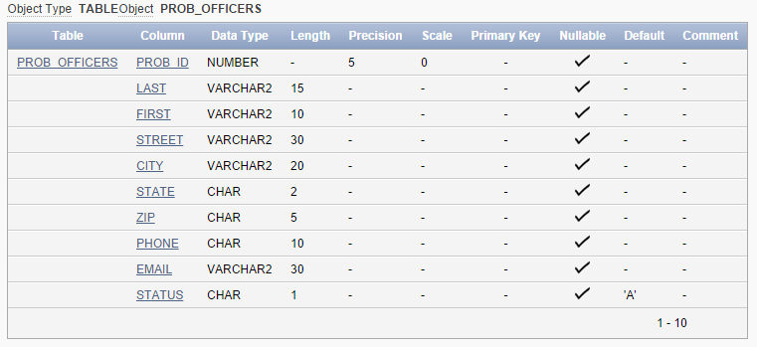

CREATE TABLE Crime_charges

(Charge_ID NUMBER(10,0),

Crime_ID NUMBER(9,0),

Crime_code NUMBER(3,0),

Charge_status CHAR(2),

Fine_amount NUMBER(7,2),

Court_fee NUMBER(7,2),

Amount_paid NUMBER(7,2),

Pay_due_date DATE);

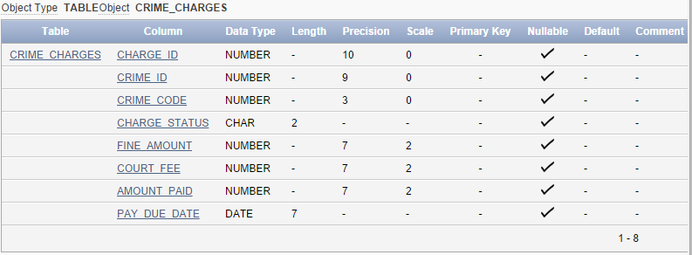

CREATE TABLE Crime_officers

(Crime_ID NUMBER(9,0),

Officer_ID NUMBER(8,0));

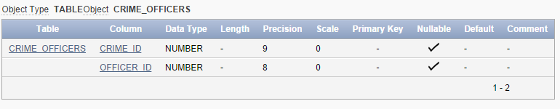

CREATE TABLE Officers

(Officer_ID NUMBER(8,0),

Last VARCHAR2(15),

First VARCHAR2(10),

Precinct CHAR(4),

Badge VARCHAR2(14),

Phone CHAR(10),

Status CHAR(1) DEFAULT 'A');

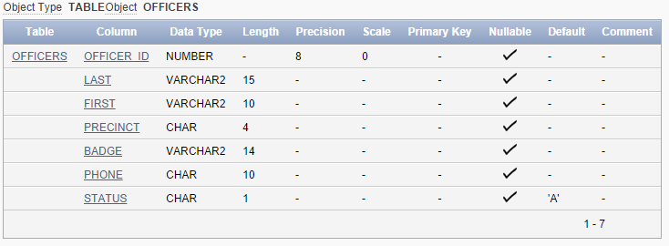

CREATE TABLE Appeals

(Appeal_ID NUMBER(5),

Crime_ID Number(9,0),

Filing_date DATE,

Hearing_date DATE,

Status CHAR(1) DEFAULT 'P');

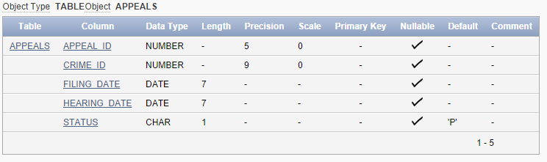

CREATE TABLE Crime_codes

(Crime_code NUMBER(3,0),

Code_description VARCHAR2(30));

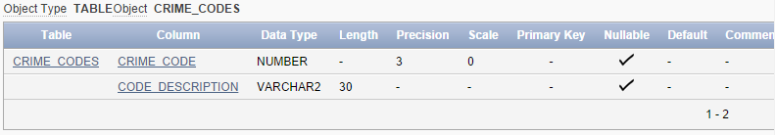

PART B

ALTER TABLE Crimes

MODIFY (Classification DEFAULT 'U');

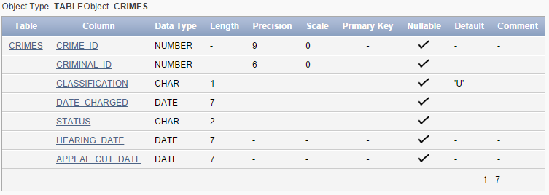

ALTER TABLE Crimes

ADD (Date_recorded DATE DEFAULT SYSDATE);

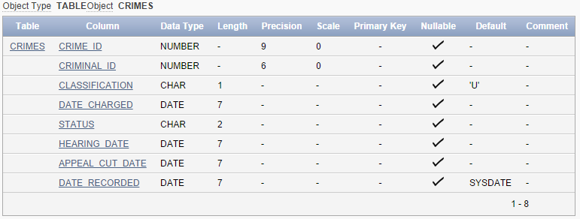

ALTER TABLE Prob_officers

ADD (Pager# Char(10));

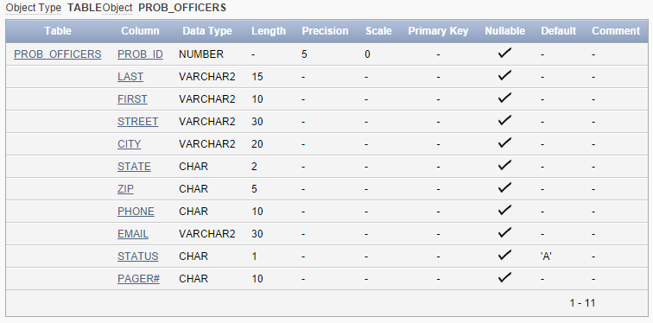

ALTER TABLE Aliases

MODIFY (Alias VARCHAR2(20));

